Training an ARSTOW Sorter

Update PE’s
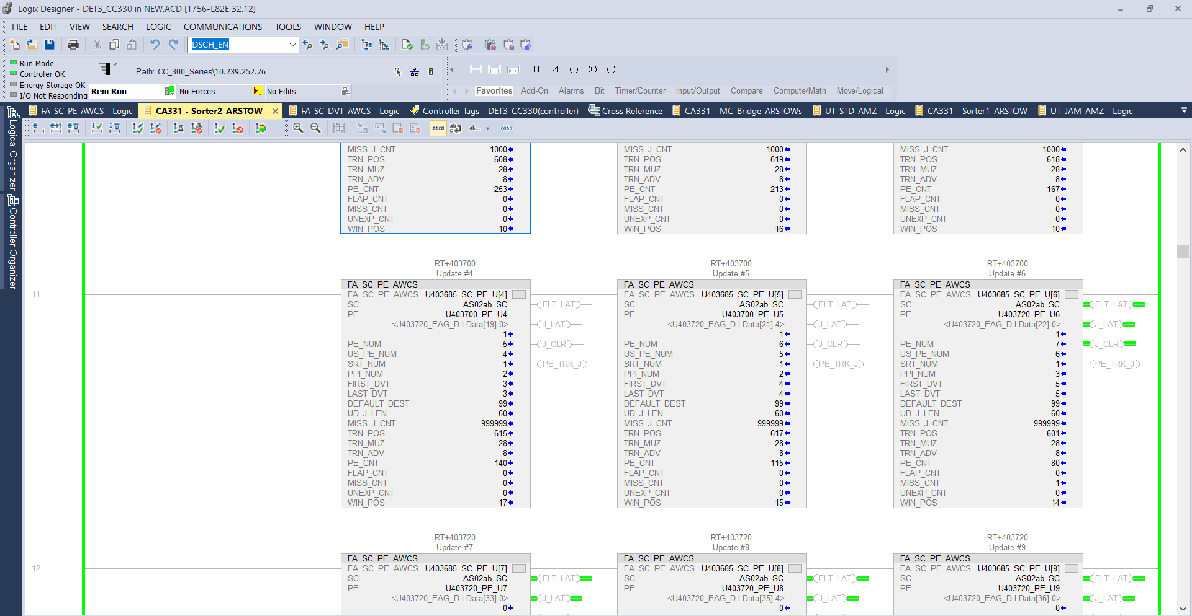

LOST_CONTAINER comes from unexpected or missed counts. If you’re getting high unexpected or missed counts, you either have a PE issue, A FIFO buffer within the update PE AOI that is full, or the training is slightly off.
Go to the “Sorter 1” or “Sorter 2” routine. Sorter 1 is for scan tunnel aa, sorter 2 is for scan tunnel ab.
Scroll down to the Update PE AOI’s. the numbers you want to pay attention to are “TRN_MUZ”, “TRN_POS”, and “WIN_POS”.
TRN_MUZ is the actual trained MUZ window calculated in PPI ticks.
TRN_POS is the number of PPI ticks it takes to travel from one UD PE to the next.
WIN_POS is the actual reading that is updated every time a tote passes that UD PE.
So if your TRN_POS is 28, the goal is to have your WIN_POS land somewhere in the middle of that number. If it is consistently between 1-8, your totes are coming in too soon. If it is between 20-28, the totes are coming in too late.
If the number goes above 28 or below 1, you get a “MISS_CNT” or a “UNEXP_CNT” which will give us a lost container.

So the magic number to aim for is 14 for your WIN_POS. Here is how you achieve that

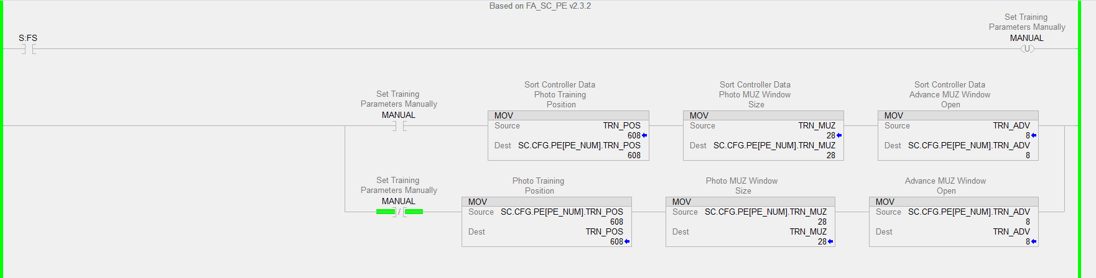

Within the Update PE AOI, toggle the manual training bit. The “TRN_POS” value is what we are changing. Only add or subtract 5-10 at a time.

Let’s assume the picture above is the AOI I want to change. If my WIN_POS is consistently low, I want to lower the TRN_POS to 600. Once you lower the value, toggle the training bit off and go back to monitoring the AOI. When the next tote goes by, look at your WIN_POS and see if it is closer to 14.

It will never always be 14. It changes every time because the totes are constantly getting bumped around, but if it is constantly hitting between 12-18 that is a good sign for us.

Do the opposite if the number is too high. Add 5 or 10 to the TRN_POS
Diverts
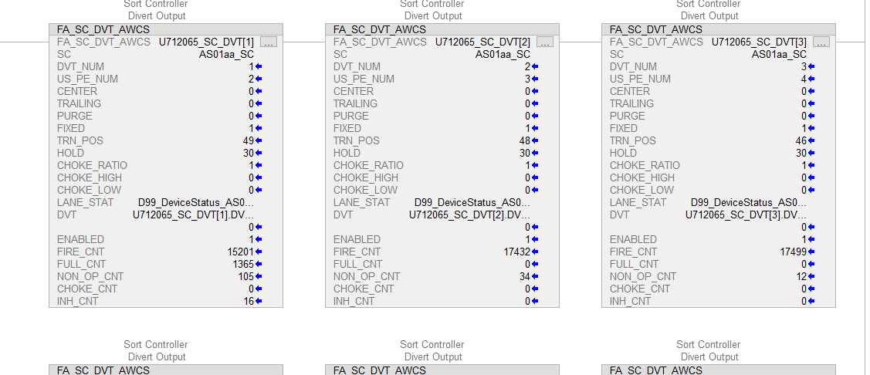
“TRN POS” = how many PPI ticks the tote needs to travel after hitting the update PE before the RAT bed solenoid pops up

“HOLD” = How long the solenoid stays popped up while transferring. This value is in PPI ticks as well. PPI ticks are usually 1” per tick. If your conveyor is running at 150fpm, then that equates to 30 inches per second. Meaning if your hold value is 30, the RAT bed stays up for 1 second. 15 would be ½ a second.

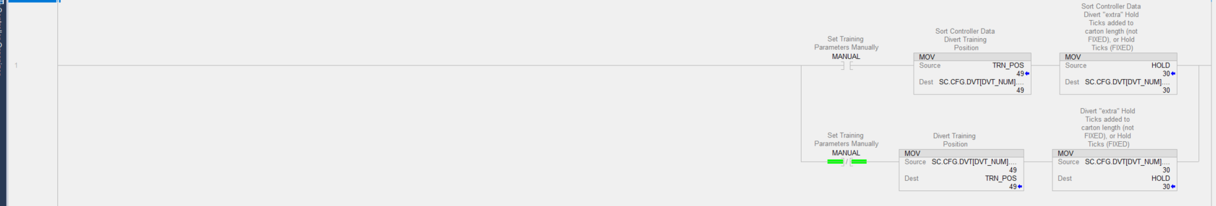

To adjust these values, go to the first rung of logic inside the divert AOI and toggle the “Manual” bit.
If the tote is travelling too far before diverting, lower the TRN POS value. Only subtract/add about 2 at a time. Once you change it, watch another couple totes divert to make sure it’s diverting properly
If the tote is not travelling far enough, raise the TRN POS value.
Once you are done, toggle the “Manual” bit off.
NOTE: Totes coming through the sorter can weigh anywhere from 1-50lbs. You want to make sure you are watching a few different totes come through the divert before walking away. Heavy & light totes will act differently when diverting. We need to find a happy medium.

The HOLD position can be adjusted in the same way. If you are having issues where the RAT stays up too long and the tote on the sorter behind the tote being diverted crashes into the RAT while it is up, you can lower the HOLD value. This will hopefully prevent that from happening
If the RAT does not stay up long enough for the tote to fully divert, you will notice that the tote spins slightly as the RAT retracts. This means you need to raise that HOLD value.
Again, only raise/lower this value by 2 at a time.

Lastly: In GEN11 buildings, there is a rung of logic that creates a short delay between the RAT popping up, and the transfer rollers running. This will usually be a TON labeled “Uxxxxxx_DVT_DLY”. If you have an issue with jams on update PE’s from a tote hitting the RAT bed as it is diverting another tote, and you have tried adjusting the HOLD value with no success, you can lower this timer. At DET3 we have this set to 100ms and it works very well.

